Lecture 13

**YUM-NWConfig-in-Centos7-8**

Yum

* When yum command is invoked 🡪 it reads a file “.repo” in (a local file)
* “.repo” contains a “url” which takes it to particular repository 🡪 here the required package is available for download,
  + In backend it uses “curl” or “wget” command
  + It downloads the “dependencies” too.
  + Then it uses 🡪 $ rpm <package_name>.rpm to installs that specific package.
* 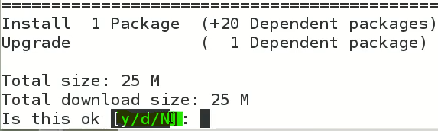
* “y” 🡪 yes install and download
* “d” 🡪 only download (do not install)
* “n” 🡪 do not download or install
* After downloading a package

$ rpm -qa | grep <package_name> 🡪 to check whether the package is installed or not

* How to configure internet on CentOS 7 & 8
* $ ifconfig 🡪 to show interfaces
* Here use,
* $ systemctl restart network 🡪 to restart the network services in CentOS 7
* Network manager is main application to configure network in CentOS 7
* After configuration restart service 🡪 $ systemctl restart NetworkManager
* 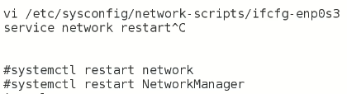
* 3 way to configure network
* 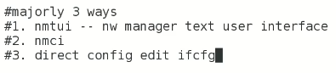
* Text

  Description automatically generated
* $ nmcli connection show <interface_name>
* $ nmcli 🡪 network configuration is an exam question
* 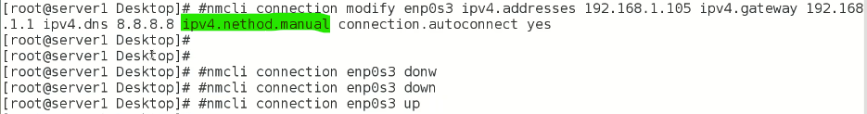
* I tried to configure without method.manual and it worked
* I’ll do it again for better understanding InnSha Allah $ nmcli
* Tip:-

The location of the DNS configuration file varies depending on the operating system and distribution. Here are some common locations for DNS configuration files in different systems:

1. Linux:
   * CentOS, Fedora, and Red Hat Enterprise Linux: **/etc/resolv.conf**
   * Debian, Ubuntu, and other Debian-based systems: **/etc/resolv.conf**
   * OpenSUSE: **/etc/resolv.conf**
   * Arch Linux: **/etc/resolv.conf**
2. macOS:
   * **/etc/resolv.conf**
3. Windows:
   * The DNS settings are stored in the registry, under **HKEY_LOCAL_MACHINE\SYSTEM\CurrentControlSet\Services\Tcpip\Parameters\Interfaces\{Adapter-ID}**.

Note: In some Linux distributions, **/etc/resolv.conf** is a symbolic link to **/run/systemd/resolve/resolv.conf**. This file is managed by the system's network manager and should not be manually edited. Any changes made to this file will be lost after a reboot. Instead, you should use the network manager's configuration tools to modify the DNS settings.